**Practice Questions**

1. Write a lex program which accepts a string beginning with 0 and ending with 1

num 0(0|1)*1

%%

{num} printf("accepted");

.+ printf("not accepted");

%%

void main()

{

printf("Enter the string:");

yylex();

}

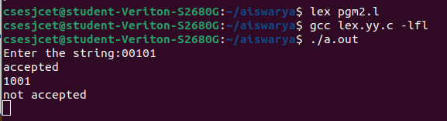

1. Implement a lexical analyser to identify tokens using LEX tool

%{

%}

%%

auto|break|case|char|const|continue|default|do|double|else|enum|extern|float|for|goto|if|int|long|register|return|short|signed|sizeof|static|struct|switch|typedef|union|unsigned|void|volatile|while printf("Keyword");

[-,+]?[0-9]+ printf("Constants");

[,.'"]+ printf("Punctuation Chars");

[!@#$%^&*()]+ printf("Special Chars");

[a-zA-Z]+ printf("Identifiers");

%%

void main()

{

printf("Enter the String:");

yylex();

}

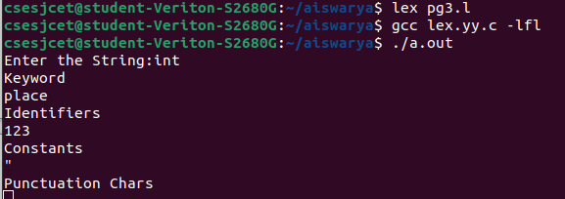

1. Implement a lexical analyser to check whether a number is odd or even using LEX tool

%{

int i;

%}

%%

[0-9]+ {i = atoi(yytext);

if(i%2==0)

printf("Even");

else

printf("Odd");

};

%%

void main()

{

printf("Enter the number:");

yylex();

}

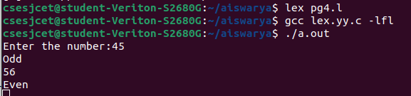

1. Implement a lexical analyser to count the number of identifiers, operators, numbers, keywords using LEX
2. Implement a calculator using LEX
3. %{  
   int op = 0,i;  
   float a, b;  
   %}  
     
   dig [0-9]+|([0-9]*)"."([0-9]+)  
   add "+"  
   sub "-"  
   mul "*"  
   div "/"  
   pow "^"  
   ln \n  
   %%   
   {dig} {digi();}   
   {add} {op=1;}  
   {sub} {op=2;}  
   {mul} {op=3;}  
   {div} {op=4;}  
   {pow} {op=5;}  
   {ln} {printf("The Answer :%f\n",a);}  
   %%  
   digi()  
   {  
   if(op==0)  
   a=atof(yytext);   
   else  
   {  
   b=atof(yytext);  
   switch(op)  
   {  
   case 1:a=a+b;  
   break;  
     
   case 2:a=a-b;  
   break;  
     
   case 3:a=a*b;  
   break;  
     
   case 4:a=a/b;  
   break;  
     
   case 5:for(i=a;b>1;b--)  
   a=a*i;  
   break;  
   }  
   op=0;  
   }  
   }  
     
   main(int argv,char *argc[])  
   {  
   printf("Enter the expression:");  
   yylex();  
   }  
     
   yywrap()  
   {  
   return 1;  
   }

